

R.R.INSTITUTE OF MODERN TECHNOLOGY

Department of Computer Science & Engineering

**HEALTH MATTERS!**

(A Website for health department)

Submitted As­

Report of MINI project

COMPUTER SCIENCE & ENGINEERING.

**SUBITTED TO :**

**MRS. DEEPSIKHA MAM**

(Asst. Professor)

Department of CSE

**Submitted By :**

1. **PRIYANSHU KUMAR (2103610100042)**
2. **PRACHI TIWARI (2103610100040)**

**CERTIFICATE**

This is to certify that this project report titled “**HEALTH MATTERS**” is the authentic work of **PRIYANSHU KUMAR** **(210361010042)** and **PRACHI TIWARI (210361010040)** who carried out the project under my supervision and guidance. They have submitted their report during the academic year 2022-2023.

The project report, in my opinion, has reached the standards fulfilling the requirement for the award of the degree of **Bachelor of Technology** in **Computer Science & Engineering** in accordance with regulations of the Institute.

**Approved & Supervised By:**

MRS. DEEPSIKHA MAM

(Asst. Professor)

Department of CSE

**Forwarded To:**

**ACKNOWLEDGEMENT**

**CONTENTS**

**TITLE PAGE………………………………………………………………………………………….1**

**CERTIFICATE………………………………………………………………………………………..2**

**ACKNOWLEDGEMENT…………………………………………………………………………….3**

**1. INTRODUCTION………………………………………………………………………………….5**

1.1 Project Definition 5  
 1.2 Objective 5  
 1.3 Scope 5

1.4 Platform Specification 5

**2.** **SYSTEM ANALYSIS…………………………………………………………………………….6**

2.1 Identification of Need 6

**3. PROJECT SNAPSHOTS………………………...…………………………………………….12**

**4. PROJECT SOURCE CODE ………………………………………………………………….26**

**5. PROJECT BENEFITS ……….…………………………………………………………………64**

**6. FUTURE ENHANCEMENT..…………….……………………………………………………...64**

**7. WEBSITES REFERENCES…………………………………………………….…………….65**

1. **INTRODUCTION**
   1. **Project Definition:**

HEALTH MATTERS! is a website for the citizens of INDIA for making them able to keep every information & every update about HEALTH AND VIRAL DISEASES. This concept may work as a digitized form for locating information to every citizen of India.

It is a website that provides listing of every information like awareness , symptoms, myths, precautions and booking slot for vaccination.

* 1. **Objective:**

Nowadays, everyone keep a smart phone in their pocket, which enables a user to do every work smartly. This website is designed keeping in mind that people should aware about the existence i\of the diseases. We can also look after the suggestions fired by the users for the better growth of this town.

* 1. **Scope of the project:**

It can be implemented all over the India.

The person living in far places and also the citizens of this town can know about the current status of symptoms of viral diseases like COVID and FLU etc.

Anyone can easily submit their problems and can request to resolve them about health issues.

* 1. **Platform Specifications:**
* **Hardware Requirements:**
* Primary Memory (RAM): 512 MB.
* Secondary Memory (Hard Disk): 2 GB.
* Video Display Unit: VGA Monitor/LCD/TFT
* Keyboard: 101 Key Enhanced Keyboard.
* Mouse: Any Mouse.
* **Software Requirements:**
* Operating System: Windows XP, vista or later
* Programming Language: Javascript
* Markup Language: HTML
* IDE: Visual studio code /Notepad++

1. **SYSTEM ANALYSIS**

**2.1: Identification of needs:**

The need for HEALTH MATTERS! arises because MATTERS! provide following points: -

* Facility to read about the details of diseases.
* Facility of booking slot for vaccination.
* Facility to read about myths of various diseases .
* Facility to post complaints and suggestions about the betterment of a health issues.
* Facility to contact with the governing authorities .
* Facility to grab various activities issued by government of India.

1. **PROJECT SNAPSHOTS**
   1. **Log-in Page** 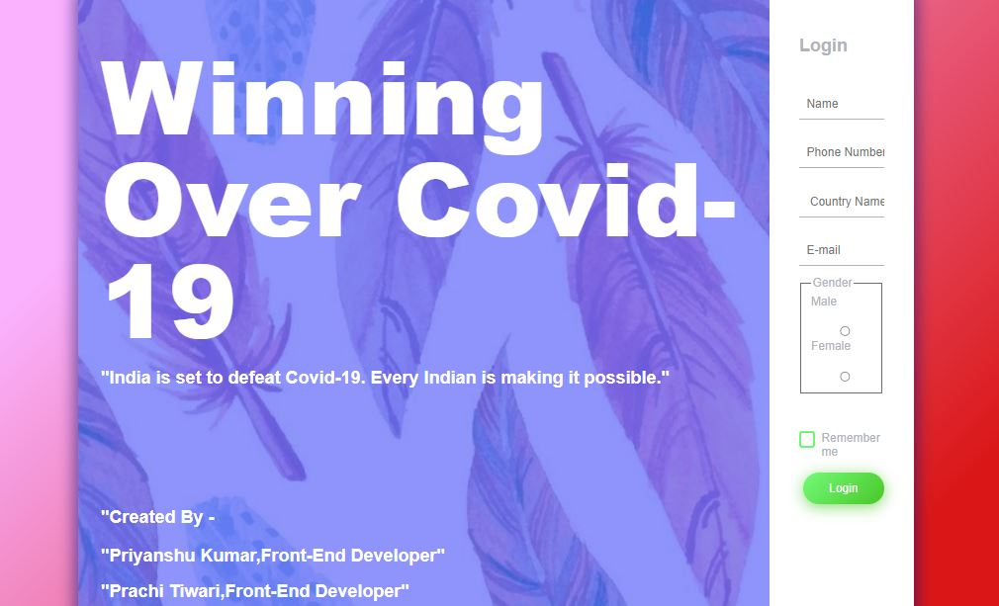

**Login credentials (Username and email)**

* 1. **Sign-up Page**

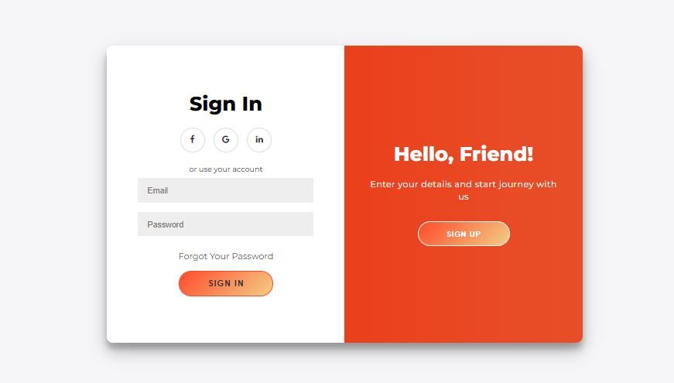

**Sign-up page of the designed user panel**

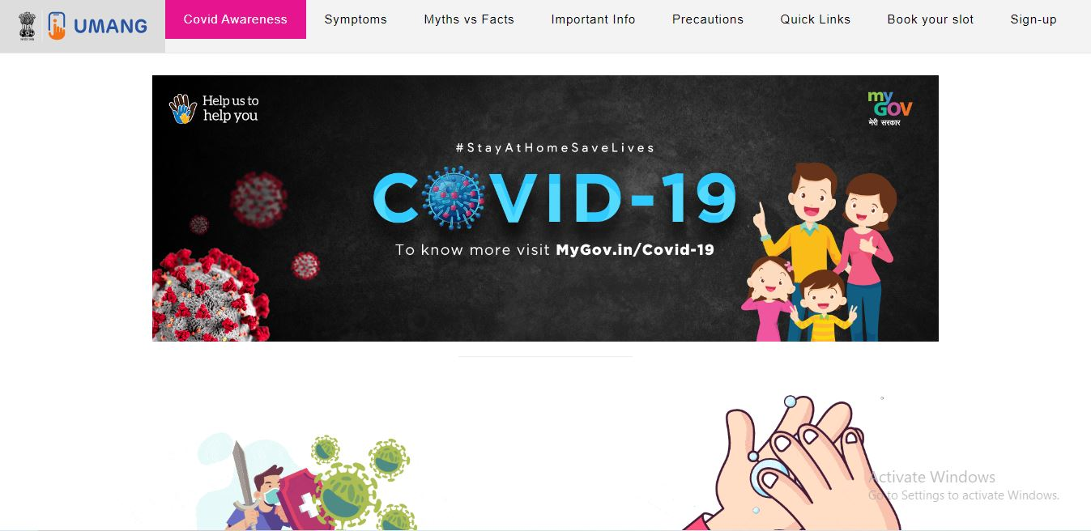

**( Home page of admin panel**

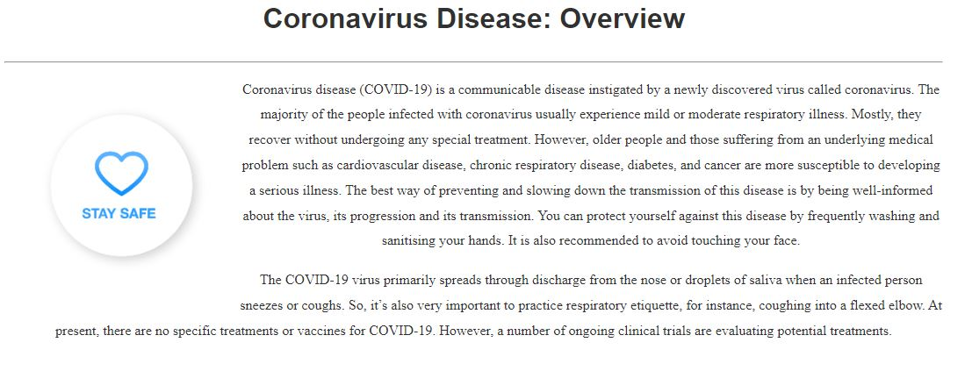

**(Overview to view the insights of COVID virus)**

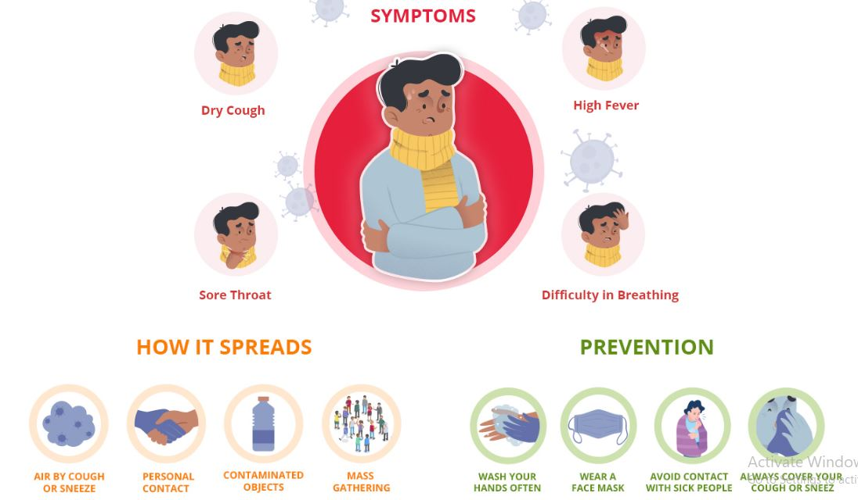

**(Symptoms of Viral diseases )**

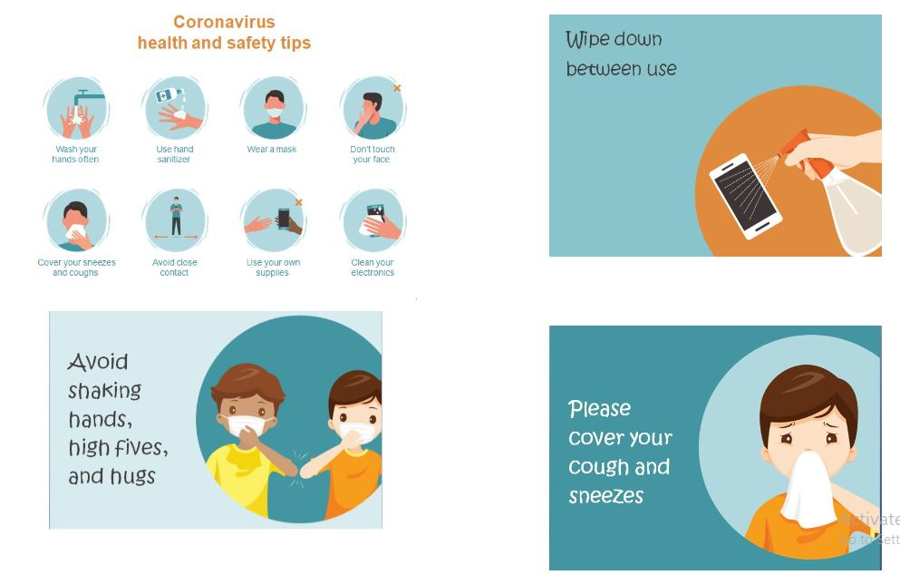

**( Precautions during viral diseases)**

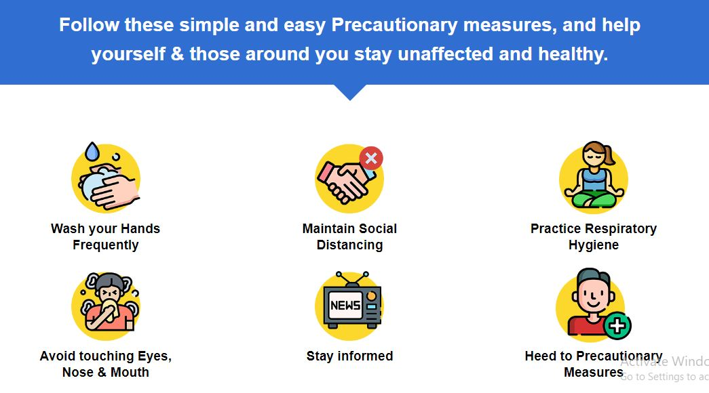**(Safety measures taken by citizens)**

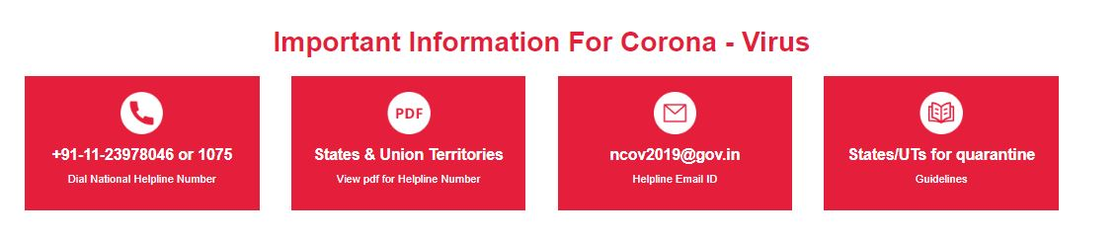

**( Important information for diseases )**

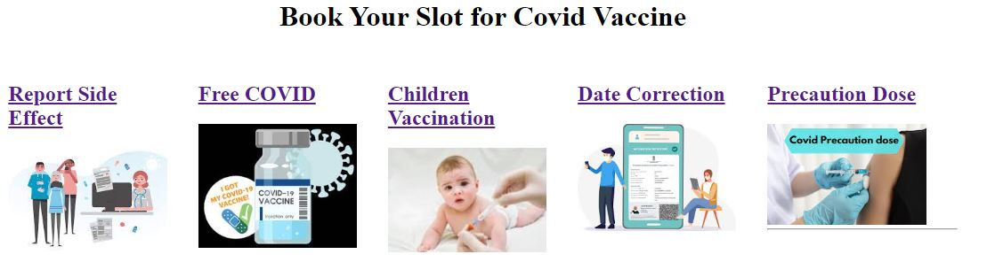

**( Book slot for vaccination )**

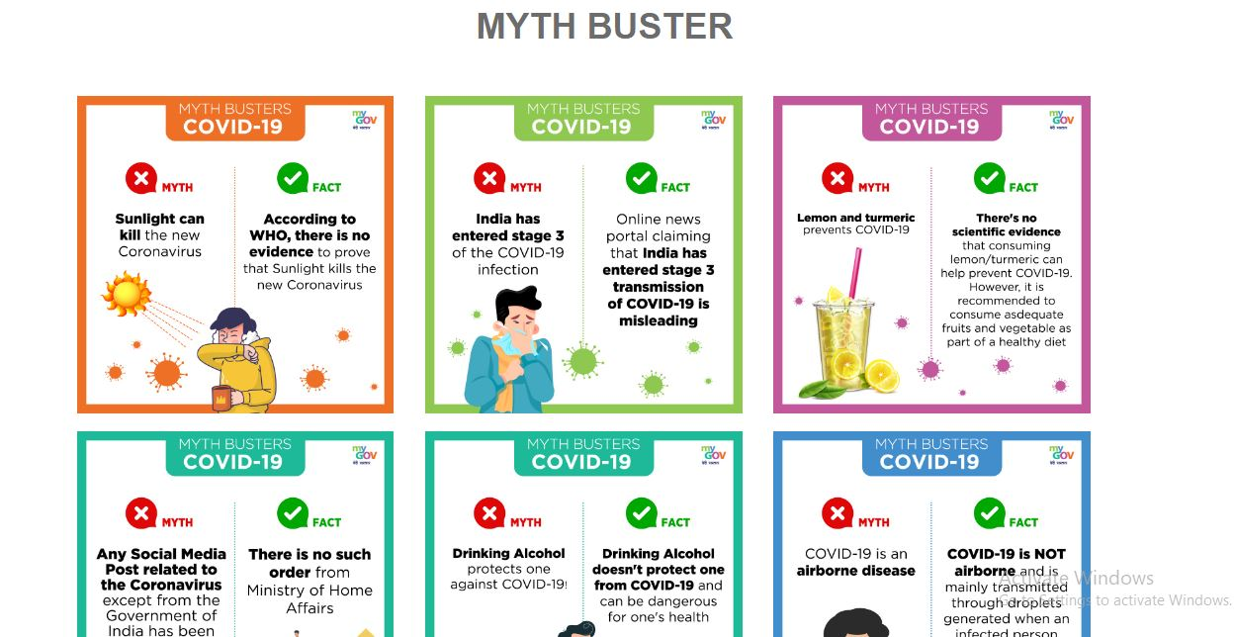**( Myths regarding covid and other viruses )**

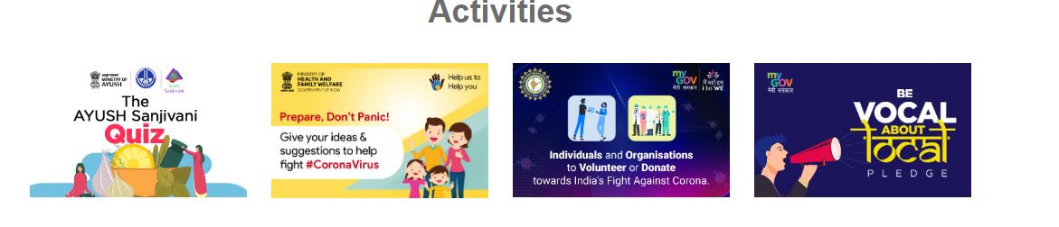

**( Activies started by Government )**

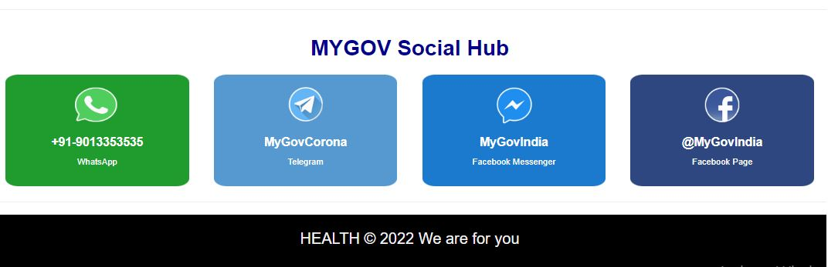

**( To contact with government during pandemic )**

1. **PROJECT SOURCE CODE**
   1. **HTMLSOURCE CODE FOR LOG-IN PAGE**

<!DOCTYPE html>

<html lang="en" >

<head>

  <meta charset="UTF-8">

  <title>Login Page in HTML with CSS Code Example</title>

  <link href="https://fonts.googleapis.com/css?family=Open+Sans" rel="stylesheet">

<link href="https://maxcdn.bootstrapcdn.com/font-awesome/4.7.0/css/font-awesome.min.css" rel="stylesheet" integrity="sha384-wvfXpqpZZVQGK6TAh5PVlGOfQNHSoD2xbE+QkPxCAFlNEevoEH3Sl0sibVcOQVnN" crossorigin="anonymous"><link rel="stylesheet" href="./login.css">

</head>

<body>

<!-- partial:index.partial.html -->

<div class="box-form">

    <div class="left">

        <div class="overlay">

        <h1>Winning Over Covid-19</h1>

        <h2>

        <p>"India is set to defeat Covid-19. Every Indian is making it possible

            <p>

                "Created By -

              <h2>  "Priyanshu Kumar,Front-End Developer" </h2>

              <h2> "Prachi Tiwari,Front-End Developer" </h2>

TO BE CONTINUED……………

4.2 **CSS SOURCE CODE FOR LOG-IN PAGE**

body {

  background-image:linear-gradient(135deg, #FAB2FF 20%, #da1717 90%);

  background-size: cover;

  background-repeat: no-repeat;

  background-attachment: fixed;

  font-family: "Open Sans", sans-serif;

  color: #B0B3B9;

}

.box-form {

  margin: 0 auto;

  width: 84%;

  background: #FFFFFF;

  border-radius: 10px;

  overflow: hidden;

  display: flex;

  flex: 1 1 100%;

  align-items: stretch;

  justify-content: space-between;

  box-shadow: 0 0 20px 6px #090b6f85;

}

@media (max-width: 980px) {

  .box-form {

    flex-flow: wrap;

    text-align: center;

    align-content: center;

    align-items: center;

  }

TO BE CONTINUED……………

**4.3 HTML SOURCE CODE FOR HOME PAGE**

<!DOCTYPE html>

<html>

<head>

    <title>Covid Awareness Website</title>

    <link rel="stylesheet" type="text/css" href="a.css">

    <link rel="stylesheet" type="text/css" href="bootstrap.min.css">

</head>

<body>

    <nav>

        <li><a href="https://web.umang.gov.in/landing/department/co-win.html" target="_blank" title="UMANG provides a single platform for all Indian Citizens to access pan India e-Gov services ranging from Central to Local Government bodies."><img src="./img/logo (1).svg" alt=""></a></li>

        <li><a class="active" href="a.html">Covid Awareness</a></li>

        <li><a href="#symptoms">Symptoms</a></li>

        <li><a href="b.html#mythbusters">Myths vs Facts</a></li>

        <li><a href="#impinfo">Important Info</a></li>

        <li><a href="#precautions">Precautions</a></li>

        <li><a href="b.html">Quick Links</a></li>

        <li><a href="b.html#bookmyslot"> Book your slot</a></li>

        <li><a  href="signlog.html">Sign-up</a></li>

        </nav>

    <div class="content">

TO BE CONTINUED……………

4.4 CSS SOURCE CODE FOR HOME PAGE

nav {

    list-style-type: none;

    margin: 1.2px solid black;

    padding: 0;

    overflow: hidden;

    border: 1px solid #e7e7e7;

    background-color: #f3f3f3;

    font-size: 17px;

  }

  nav li {

    float: left;

  }

  nav li a {

    display: block;

    color: black;

    text-align: center;

    padding: 15px 25px;

    text-decoration: none;

    /*word-spacing: 2px;*/

    letter-spacing: 0.8px;

  }

  nav li a:hover:not(.active) {

    background-color: #ddd;

    text-decoration: none;

    text-underline-position: none;

  }

  nav li a.active {

TO BE CONTINUED……………

4.5 HTML SOURCE CODE FOR CONTENT PAGE

<!DOCTYPE html>

<html>

<head>

    <title>Covid Awareness Website</title>

    <link rel="stylesheet" type="text/css" href="b.css">

    <link rel="stylesheet" type="text/css" href="a.css">

</head>

<body>

<nav class=>

        <li><a href="https://web.umang.gov.in/landing/department/co-win.html" target="_blank" title="UMANG provides a single platform for all Indian Citizens to access pan India e-Gov services ranging from Central to Local Government bodies."><img src="./img/logo (1).svg" alt=""></a></li>

        <li><a href="a.html" class="active">Covid Awareness</a></li>

        <li><a href="a.html">Symptoms</a></li>

        <li><a href="#mythbusters">Myths vs Facts</a></li>

        <li><a href="a.html">Important Info</a></li>

        <li>

TO BE CONTINUED……………

4.6 CSS SOURCE CODE FOR CONTENT PAGE

#nav{

  display: flex;

}

.quicklinks {

  margin: 0 auto;

}

.slot{

  float: left;

  width: 20%;

  padding: 15px 35px 0 0;

  transition: transform .8s ease-in-out;

}

.infoboxes{

  margin-bottom: 20px;

  display: flex;

  justify-content:space-between;

  flex-wrap: wrap;

}

.infoboxes a {

TO BE CONTINUED……………

4.6 HTML SOURCE CODE FOR SIGN UP PAGE

<!DOCTYPE html>

<html>

<head>

    <title>SignUp and Login</title>

    <link rel="stylesheet" type="text/css" href="signlog.css">

    <link rel="stylesheet" href="https://cdnjs.cloudflare.com/ajax/libs/font-awesome/4.7.0/css/font-awesome.min.css">

</head>

<body>

<div class="container" id="container">

<div class="form-container sign-up-container">

<form action="connect.php" method="post">

    <h1>Create Account</h1>

    <div class="social-container">

        <a href="#" class="social"><i class="fa fa-facebook"></i></a>

        <a href="#" class="social"><i class="fa fa-google"></i></a>

        <a href="#" class="social"><i class="fa fa-linkedin"></i></a>

TO BE CONTINUED……………

4.6 CSS SOURCE CODE FOR SIGN UP PAGE

@import url('https://fonts.googleapis.com/css?family=Montserrat:400,800');

* {

    box-sizing: border-box;

}

body {

    background: #f6f5f7;

    display: flex;

    justify-content: center;

    align-items: center;

    flex-direction: column;

    font-family: 'Montserrat', sans-serif;

    height: 100vh;

    margin: -20px 0 50px;

}

h1 {

    font-weight: bold;

    margin: 0;

}

h2 {

TO BE CONTINUED……………

**5.PROJECT BENEFITS**

* User will be able to explore and find important information about health issues.
* As it is a website, so it is accessible to everyone 24 * 7.
* Website is simple and easy to use.
* Website is responsive.
* As it is a website ,it will be be regularly maintained and will get updates in future.
* You can easily search for myths , symptoms, information, about various diseases.

**6.FUTURE ENHANCEMENTS**

* Sytem can be extended for other users.
* More information about diseaeses.
* Description can be increased for many diseases .
* This website will be connected with government to help citizens during pandemic.

7. REFERENCES

* Images used in project is taken from Image search results https://unsplash.com/s/photos/covid
* Social media icons are taken from other websites.

https://www.flaticon.com/free-icons/social-media

* Links for vaccination and various activities issued by government are taken by government website .

https://www.cowin.gov.in/

THANK YOU !